Justification for 1 Dimensional CNN
The selected architecture is a 1D Convolutional Neural Network (Conv1D), which is particularly well-adapted to process sequential or time-series input data. Compared to traditional dense networks, 1D CNNs are able to learn local temporal patterns and dependencies over neighboring time steps and are thus very powerful at learning temporal feature representations.

Key Architectural Components and Rationale
- 1D Convolutional Layers (Conv1D):
  - Perform convolution operations along the temporal axis.
  - Learn local temporal dependencies between consecutive time steps.
  - Computationally efficient and parallelizable compared to recurrent models (e.g., LSTMs).
- Multiple Convolutional Blocks with Increasing Filters (64 → 128 → 256):
  - Gradually increasing filter sizes allow hierarchical feature learning.
  - Early layers capture simple, short-term patterns.
  - Deeper layers extract more complex, long-term dependencies.
- Varying Kernel Sizes (7, 5, 3):
  - Different kernel sizes capture patterns at multiple temporal scales.
  - Smaller kernels detect fine-grained details, while larger ones capture broader temporal structures.
- Batch Normalization:
  - Normalizes activations to stabilize and speed up training.
  - Reduces internal covariate shift and improves model convergence.
- MaxPooling1D Layers:
  - Down-sample the temporal dimension to reduce computational cost.
  - Increase the receptive field and help extract position-invariant features.
- Dropout Layers:
  - Randomly deactivate a fraction of neurons during training.
  - Acts as a regularization method to reduce overfitting and enhance generalization.
- Dense (Fully Connected) Layers:
  - Aggregate learned features from convolutional layers.
  - Map high-level representations to class outputs.
  - Use ReLU for non-linearity and softmax for class probability distribution.
- Softmax Activation with Sparse Categorical Crossentropy:
  - Standard configuration for multi-class classification with integer-encoded labels.
  - Provides stable training and interpretable probabilistic outputs.

Layers
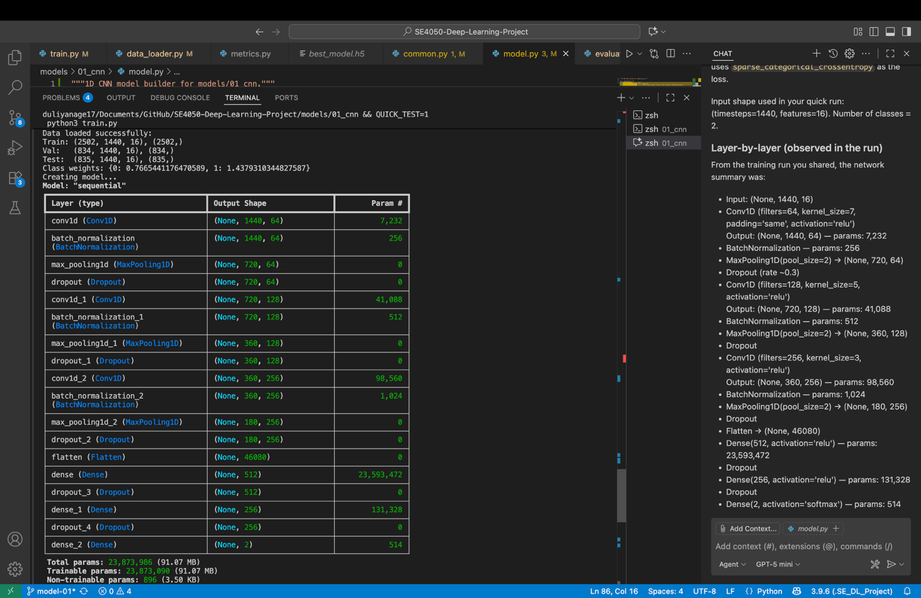

Layer-by-layer (observed in the run)
From the training run you shared, the network summary was:
- Input: (None, 1440, 16)
- Conv1D (filters=64, kernel_size=7, padding='same', activation='relu')
Output: (None, 1440, 64) — params: 7,232
- BatchNormalization — params: 256
- MaxPooling1D(pool_size=2) → (None, 720, 64)
- Dropout (rate ~0.3)
- Conv1D (filters=128, kernel_size=5, activation='relu')
Output: (None, 720, 128) — params: 41,088
- BatchNormalization — params: 512
- MaxPooling1D(pool_size=2) → (None, 360, 128)
- Dropout
- Conv1D (filters=256, kernel_size=3, activation='relu')
Output: (None, 360, 256) — params: 98,560
- BatchNormalization — params: 1,024
- MaxPooling1D(pool_size=2) → (None, 180, 256)
- Dropout
- Flatten → (None, 46080)
- Dense(512, activation='relu') — params: 23,593,472
- Dropout
- Dense(256, activation='relu') — params: 131,328
- Dropout
- Dense(2, activation='softmax') — params: 514
Total params (from run): 23,873,986 (trainable ~23.87M)
Activations Used
- Hidden conv/dense layers: ReLU
- Output layer: softmax (2 output units)
- Loss: sparse_categorical_crossentropy
- Optimizer: Adam (default lr=0.001)
Note: ReLU is used throughout for non-linearity; softmax maps final logits to class probabilities
Performance
=== CNN_Model Results ===
Test Accuracy: 0.861
Sensitivity: 0.981
Specificity: 0.778
ROC AUC: 0.990
🎯 CNN_Model Evaluation Results:
==================================================
Accuracy: 0.861
Precision: 0.755
Recall: 0.981
F1-Score: 0.853
Sensitivity: 0.981
Specificity: 0.778
ROC AUC: 0.990
==================================================
✅ Evaluation complete! Results saved to results/model_performance/
Data loaded successfully:
Train: (2717, 1440, 16), (2717,)
Val: (697, 1440, 16), (697,)
Test: (757, 1440, 16), (757,)
24/24 ━━━━━━━━━━━━━━━━━━━━ 1s 21ms/step

🔍 Misclassification Analysis:
Total misclassified: 105/757 (13.9%)
False Positives (Control predicted as Condition): 99
False Negatives (Condition predicted as Control): 6
